**REST - Country Web Service**

**Step-1: Created as per given**

**URL**: /country  
**Controller**: com.cognizant.spring-learn.controller.CountryController  
**Method Annotation**: @RequestMapping  
**Method Name**: getCountryIndia()  
**Method Implementation**: Load India bean from spring xml configuration and return  
**Sample Request**: <http://localhost:8083/country>

**Step-2: CountryController.java**

**package** com.cognizant.spring_learn.controller;

**import** com.cognizant.spring_learn.Country;

**import** org.slf4j.Logger;

**import** org.slf4j.LoggerFactory;

**import** org.springframework.context.ApplicationContext;

**import** org.springframework.context.support.ClassPathXmlApplicationContext;

**import** org.springframework.web.bind.annotation.RequestMapping;

**import** org.springframework.web.bind.annotation.RestController;

@RestController

**public** **class** CountryController {

**private** **static** **final** Logger ***LOGGER*** = LoggerFactory.*getLogger*(CountryController.**class**);

@RequestMapping("/country")

**public** Country getCountryIndia() {

***LOGGER***.info("START: getCountryIndia()");

ApplicationContext context = **new** ClassPathXmlApplicationContext("country.xml");

Country country = context.getBean("country", Country.**class**);

***LOGGER***.info("END: getCountryIndia()");

**return** country;

}

}

**Output:**

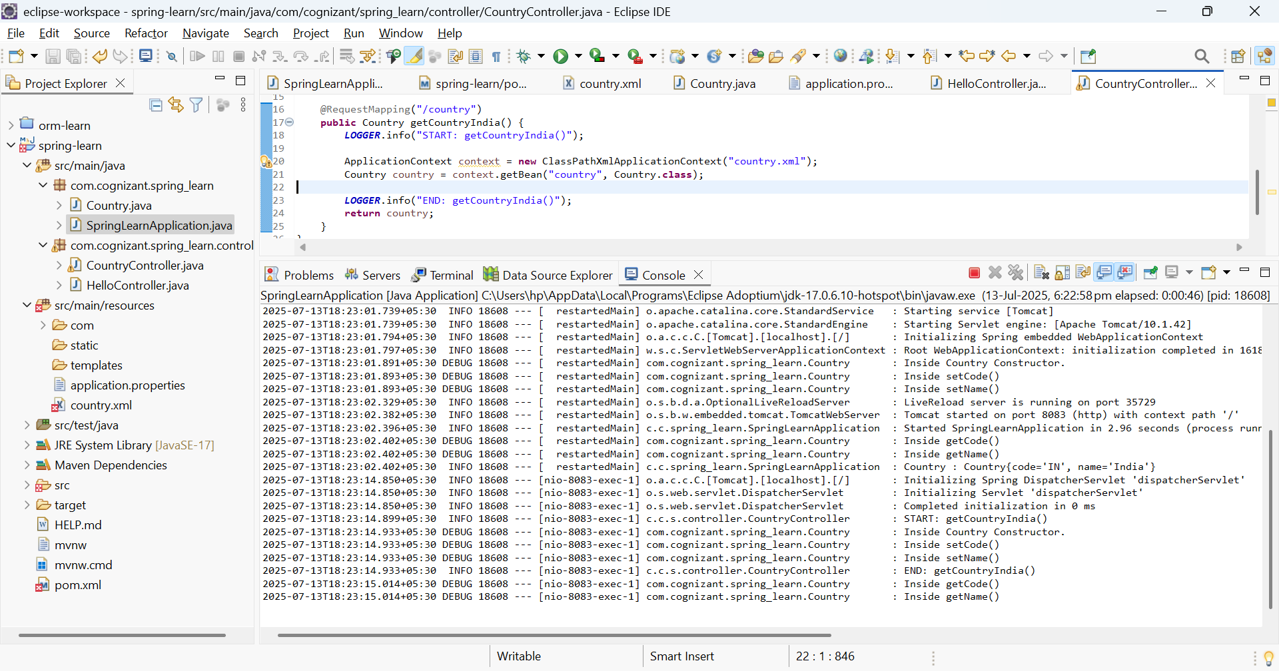

**Step-3**;Output of webbrowser in [**http://localhost:8083/country**](http://localhost:8083/country) **and postman**

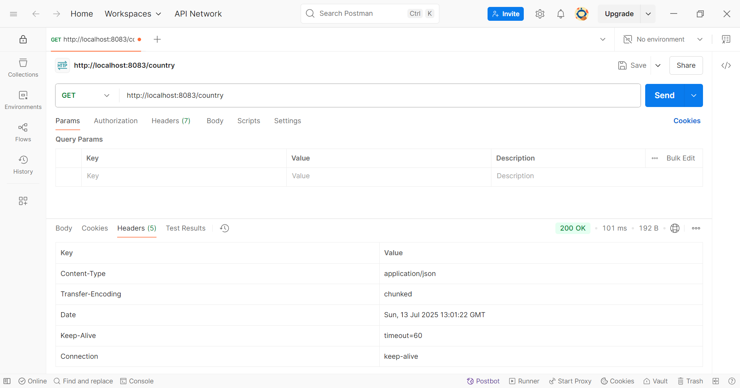

**Post man**

